ASSIGNMENT - 2

**CE 206 – HUMAN COMPUTER INTERACTION**

DONE BY: **Waleed Bin Asad**

REGISTERTION NUMBER: **1805967**

**TASK 1**

As mentioned in the design brief, I have to create a full responsive website, suitable on mobile devices, iPad’s, laptops etc. The website I’ve designed has multiple pages, each of which describes features of Irene Au. So my design from the Site map is :

**Section of Contents**

**HOME**

As seen from Figure.1, the home section contains 5 navigation buttons. The first three (“ABOUT”, “PROJECTS”, “SERVICES”) is included on the home page so when the user clicks on them it scrolls down to that specific section. Two of them redirect to another page. So “Contact” takes the user to the contact form page. “Blogs” navigation link takes redirects the user to recent blogs page.

**ABOUT**

As seen from Figure.1, the about section contains two parts biography and image. The biography will describe about her past life, how she got motivated as a UX designer, with her image beside it. It will also include a button link which takes to inner page, briefing more about herself. This is going to be an external link, which takes to her main page and it describes about her hobbies, poems etc.

**SERVICES**

As seen from Figure.1 below, the service section contains three parts. There are going to be three boxes included. This will show her brief knowledge in UX designing. First one for yoga session which includes a button that redirects to another page. This page will let user’s books into upcoming yoga session. The second box is about here upcoming events. This is something important which can motivate clients in field of UX design. The third box is UX design, clients can contact her if they need any guidance in designing webpages. This is really important feature.

**PROJECTS**

As seen from Figure.1, the project section is going to show her past experience about all the projects she has done. This includes her being part of Google, yahoo team.

**BLOGS**

As seen from Figure.1 below, the blog section contains two parts. This is her recent blogs she has posted. One of them is about design. It gives all the description about design being as important in technology. Also the other one is about Internship Programs etc.

**CONTACT**

As seen from Figure.1 below, the contact section contains one page. There a contact form displayed, which can allow users to contact her directly for any of her services. It is important because someone who wants to learn more about UX design then Irene is going to be her role model.

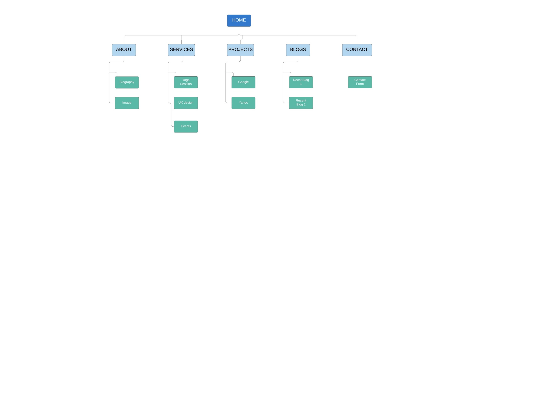Below is the site map that appear users to see pages and navigation buttons. First Three of them are navigation buttons to the same page. Whereas the other two redirects to another page briefing more about her. There are some inner pages which redirects to the main page briefing more about Irene.

*Figure.1 Site map*

Here are the contents that will be added in my webpage:

**ABOUT**

A quote will be added:

“The next big thing is the one that makes the last big thing usable”

Her picture will be added:



This section is **about herself**

*“I am an operating partner at* [*Khosla Ventures*](http://www.khoslaventures.com/)*, working with portfolio companies to make their design and UX great. I build high performing teams, establish design practices, mentor and grow the next generation of great designers, and design interfaces and experiences. I drive strategic discussions at the highest levels of companies, focusing first on user needs to inspire product innovation.*

*As former head of the design teams for Google and Yahoo, I have been one of the biggest employers of UX talent. I have led design and user experience at Google, Yahoo, Netscape, and Udacity.*

*I was first introduced to yoga at the age of 16 and recommitted to my practice when my hectic career and passion for group exercise and fitness led me to pursue yoga for its many benefits. I draw on many styles of yoga, combining choreographed flow sequences with proper alignment to make yoga accessible yet challenging. My sequences are well-rounded, with a focus on safety, joining movement with breath, and having fun. “*

The **button** link will redirect to <https://www.designbetter.co/podcast/irene-au> for more brief information about Irene.

**SERVICES**

The **first** box contains about her yoga session and some content.

“*I was first introduced to yoga at the age of 16 and recommitted to my practice when my hectic career and passion for group exercise and fitness led me to pursue yoga for its many benefits. I draw on many styles of yoga, combining choreographed flow sequences with proper alignment to make yoga accessible yet challenging. My sequences are well-rounded, with a focus on safety, joining movement with breath, and having fun.”*

It has a button which redirects to <https://ireneau.com/yoga-teaching-schedule/>

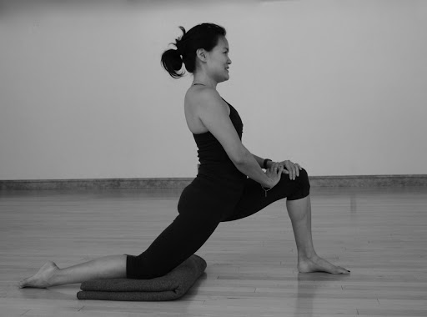It also includes a background image

This is her schedule where the users are redirected to.

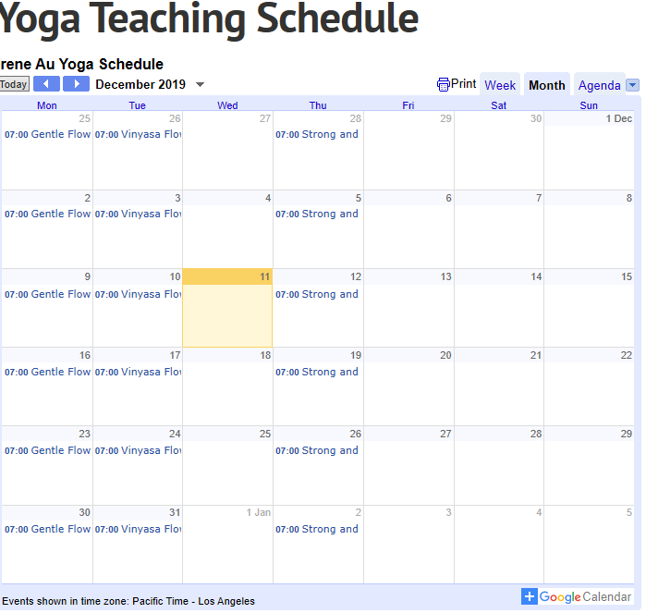

The **second** box contains about her event talks. The content added is

“*Unfortunately there are no upcoming events. Although if you are interested in listening to my previous talks then you can click the following links below.*

* <https://womentalkdesign.com/talks/design-is-as-critical-as-technology/>
* <https://womentalkdesign.com/talks/cultivating-empathic-design-in-an-analytical-world/>

*”*

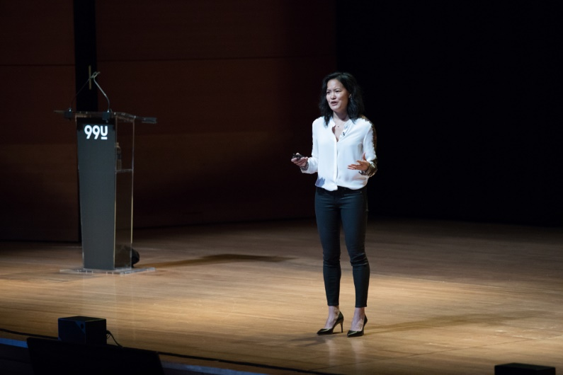It will also include a background image

The **third** box contains about UX design services she can provide. It has some content relating it to her past experience.

*“Irene has unprecedented experience elevating the strategic importance of design within internet companies, having built and led and entire User Experience and Design teams at Google (2006-2012), Yahoo! (1998-2006), and Udacity (2012-2014). She began her career as an interaction designer at Net scape Communications, where she worked on the design of the internet’s first commercial web browser.*

*If you want any services please feel free to contact me.”*

It will also include a background image



**PROJECTS**

She has worked in couple of big companies and the content going to be added

1. Google

*******“* [*Irene Au*](https://www.linkedin.com/in/ireneau/)*spent the majority of her career working to scale up large consumer internet companies. She began as an interaction designer at Netscape, working on the first commercial web browser. Then in 1998, she joined Yahoo where she worked for eight years, leading the design team and introducing user-centered design practices. She continued in a similar role when she went to Google in 2006 and was responsible for scaling the company’s design team to more than 250 members. “*

1. Yahoo

*“At Yahoo, when I first joined, people thought of design as being really about aesthetics and making things look good,” she said. “And so I spent a lot of my time in the early days, explaining to people that design was not just about how things look, but how they work.”*

**BLOGS**

There are two recent blogs she has done. So the text added for the first one will be.

***“UX Is a Canary in a Coal Mine*” ---** This is the heading of the blog

“ Most designers naturally want to join a company where the design of the product is already strong, believing it reflects the value the company places on design and how well designers are set up to succeed… ”

There will be a button which has will redirect to a more in detail page about that blog.

The link is <https://ireneau.com/2015/08/19/ux-is-a-canary-in-a-coal-mine/>

The second blog is.

***“Khosla Ventures Design Internship Program”* ---** This is the heading

*“Design is a profession where people learn by doing.  The best designers are making all the time.  They have personal side projects; they’re constantly inventing and reinventing...”*

There will be a button which has will redirect to a more in detail page about that blog.

The link is <https://ireneau.com/2015/02/27/khosla-ventures-design-internship-program/>

**CONTACT**

There won’t be any contents. There it’s just going to be one contact form where clients can contact her, if they need any services. They can also contact her through Social Media, if they want.

**Future Clients**

**User Personas**

1. 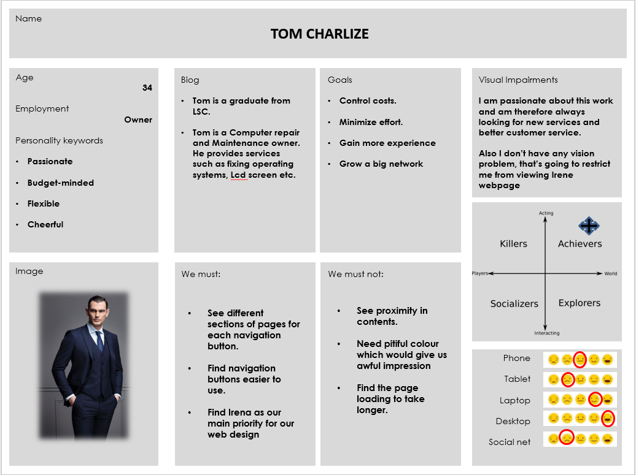
2. 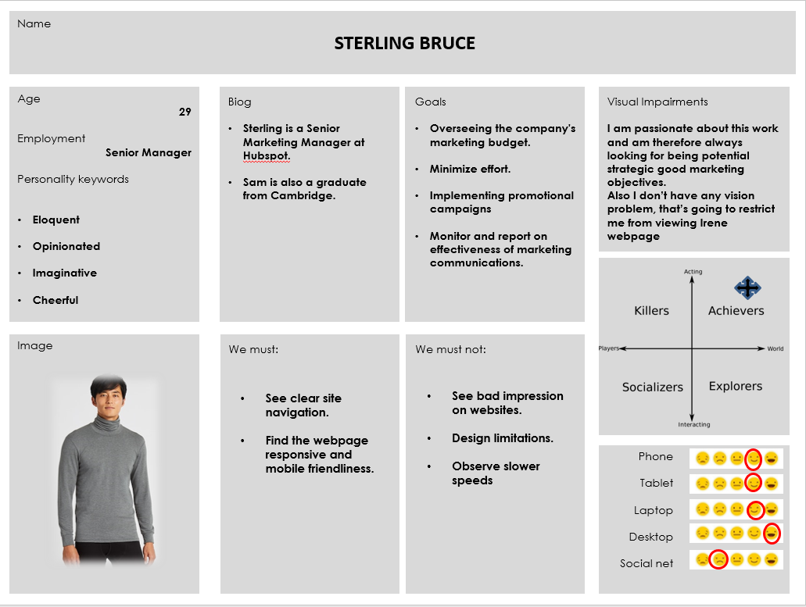
3. 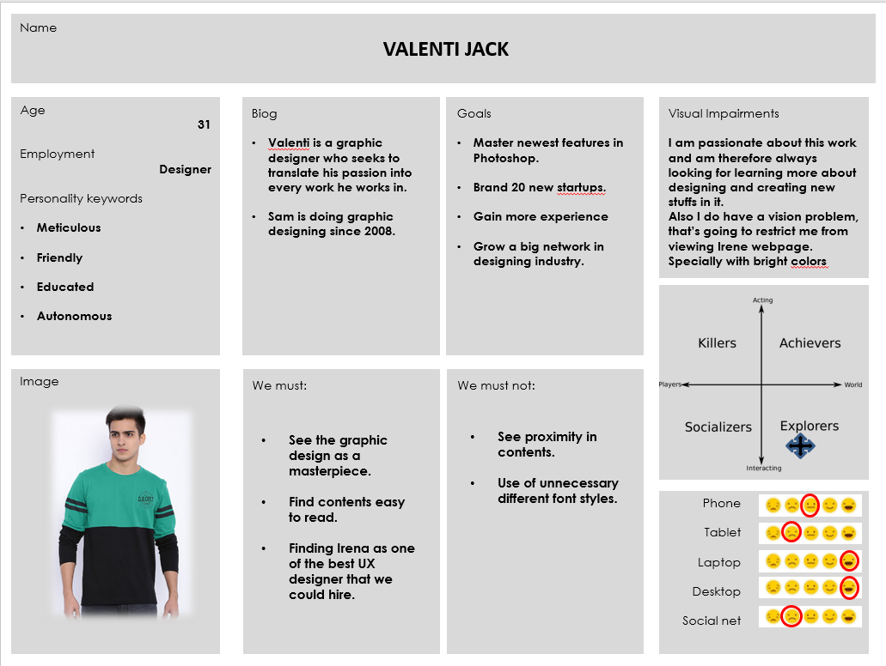
4. 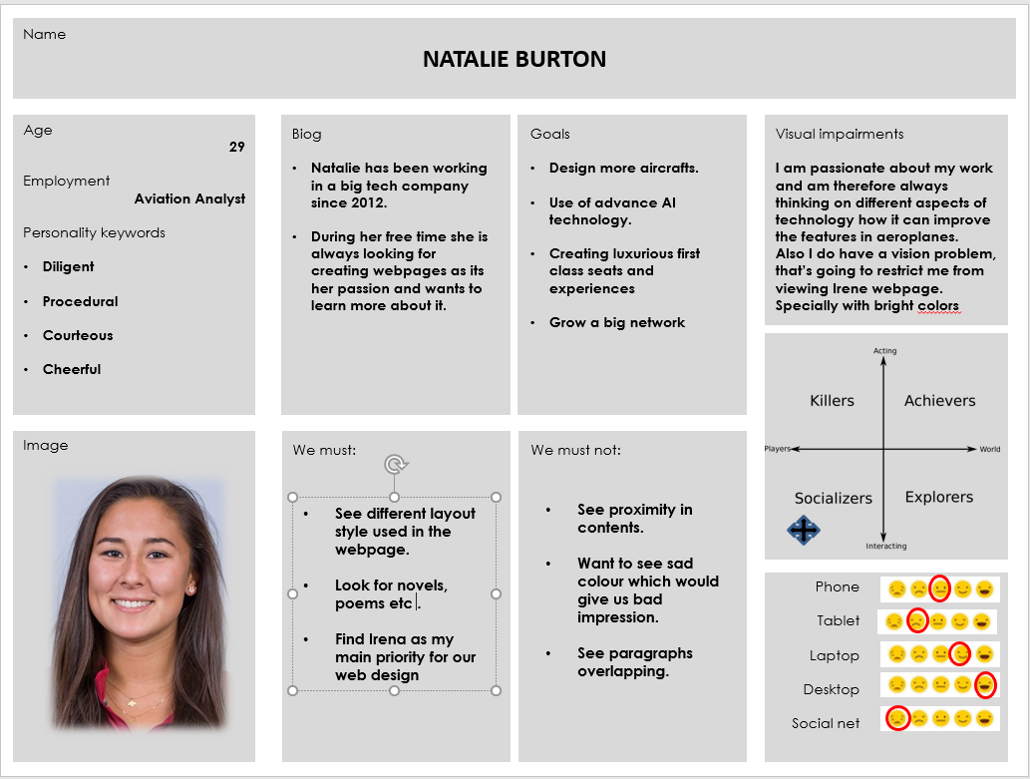

**User Stories**

This section I was asked to assign user stories for my future clients that would be access Irene’s webpage. So the one’s I’ve chose are Designer, Owner, Aviavtion analyst, Senior manager.

1. **Owner (Tom Chalize)**

As a **<role>** company owner **</role>,** I want **<goal>**to get in touch **</goal>** with Irene, so I **<benefit>** can hire and benefit from her UX designing **</benefit>.**

1. **Senior Manager (Sterling Bruce)**

As a **<role>** senior manager **</role>,** I want **<goal>**to have a look on her projects **</goal>**, so I **<benefit>** could value my companies marketing budget **</benefit>.**

1. **Designer (Valenti Jack)**

As a **<role>** designer **</role>,** I want **<goal>**to have a look at Irene designing projects, what she has contributed in it **</goal>**, so I **<benefit>** could improve my designing **</benefit>.**

1. **Aviation analyst (Natalie Burton)**

As a **<role>** Avaition analyst **</role>,** I want **<goal>**to have a look at Irene recent accomplishments **</goal>**, so I **<benefit>** could be motivated in it**</benefit>.**

**User Journeys**

In this section, there is going to be potential user who are willing to access Irene’s webpage for some purpose.

**Booking in Yoga classes**

1. User access Irene’s Webpage
2. Click the navigation button for services
3. User is redirected to that specific section
4. User clicks on the yoga button
5. Books in the Schedule from her Calendar
6. Gets a confirmations
7. Leave the Website

**Booking in for her Event talks**

1. User access Irene’s Webpage
2. Clicks the navigation for services
3. Redirected to that specific content
4. Finds the Event button
5. Redirected to her event talks page
6. Because currently no tasks available

**Users looking for her blogs**

1. User access Irene’s Webpage
2. Clicks on the blog navigation button
3. Redirected to another page
4. Views the blogs they want to read about
5. Clicks that blog and is redirected to more information about that specific blog
6. Gets satisfies
7. Leave the Webpage

**Users looking for Contacting Irene**

1. Users access Irene’s Webpage
2. Clicks on the contact navigation button
3. Redirected to contact page
4. Few option available Social Media
5. Fill out a contact form
6. Send the message
7. Leave the website

**Wireframes**

This is the design of my Home Page.

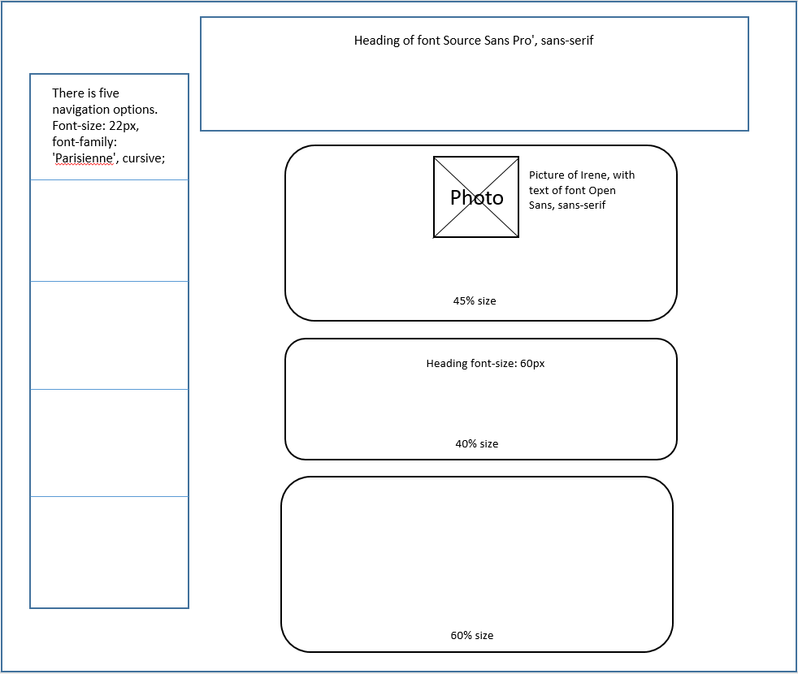

This is the design of my Blog Page.

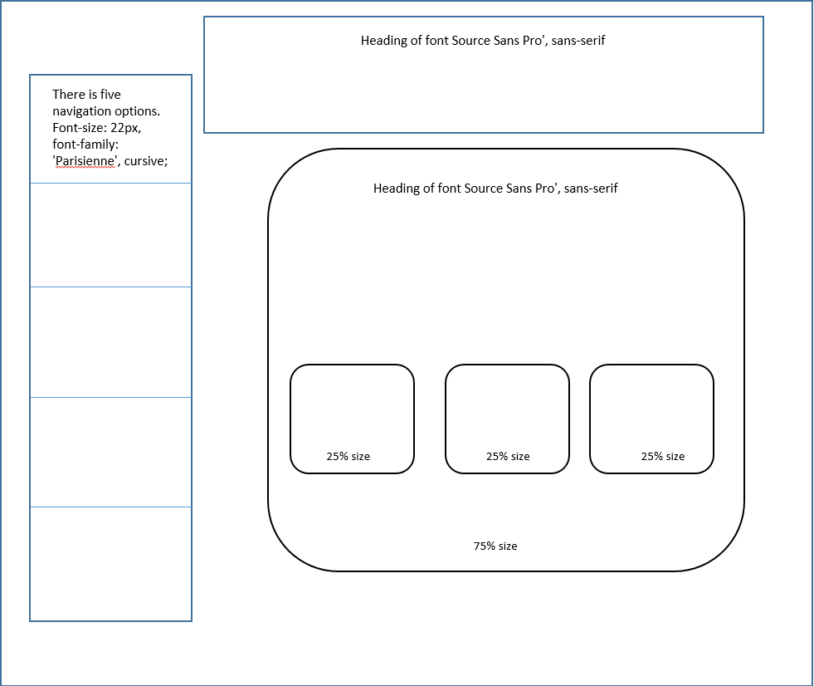

This is the design of my Contact Page.

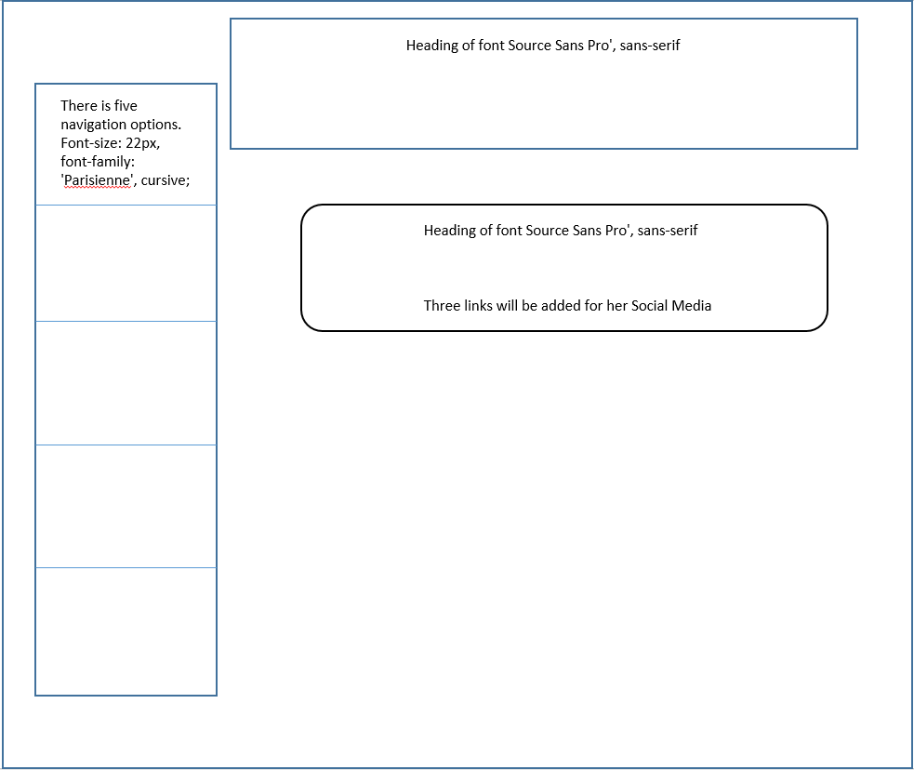

**TASK 2**

**Inspiration for Website Design**

1. <https://www.instagram.com/>

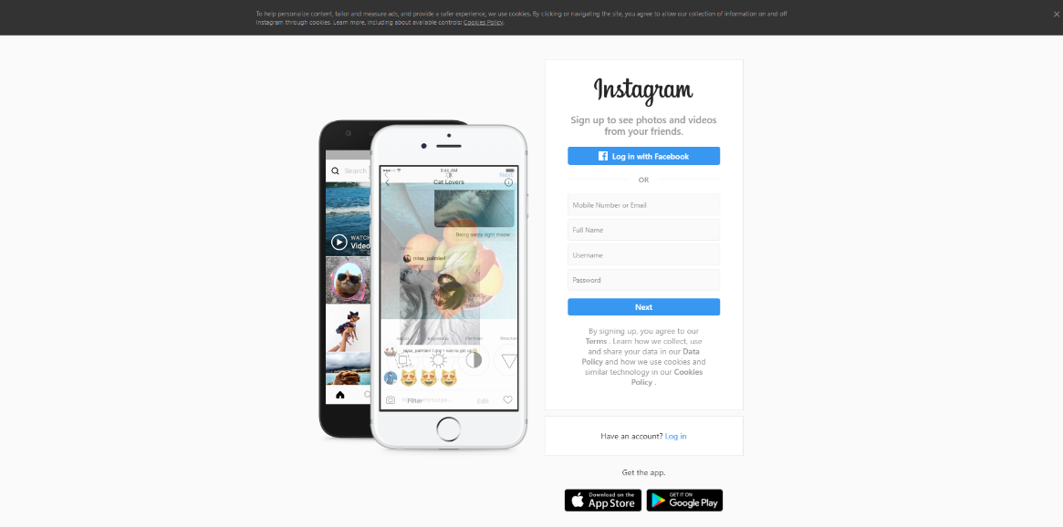

Instagram is similar to Irene’s website, because it talks about the design. How everything structured in it. It’s really responsive ad super friendly for people to use. The thing that motivate me is the story section where you can upload live stories etc. It is widely organised and you can get many sponsorships. Something that are not in Irene webpage is the live story and the search button. This is a really cool feature that can be added to my design.

1. <https://universalwebdesign.co.uk/>

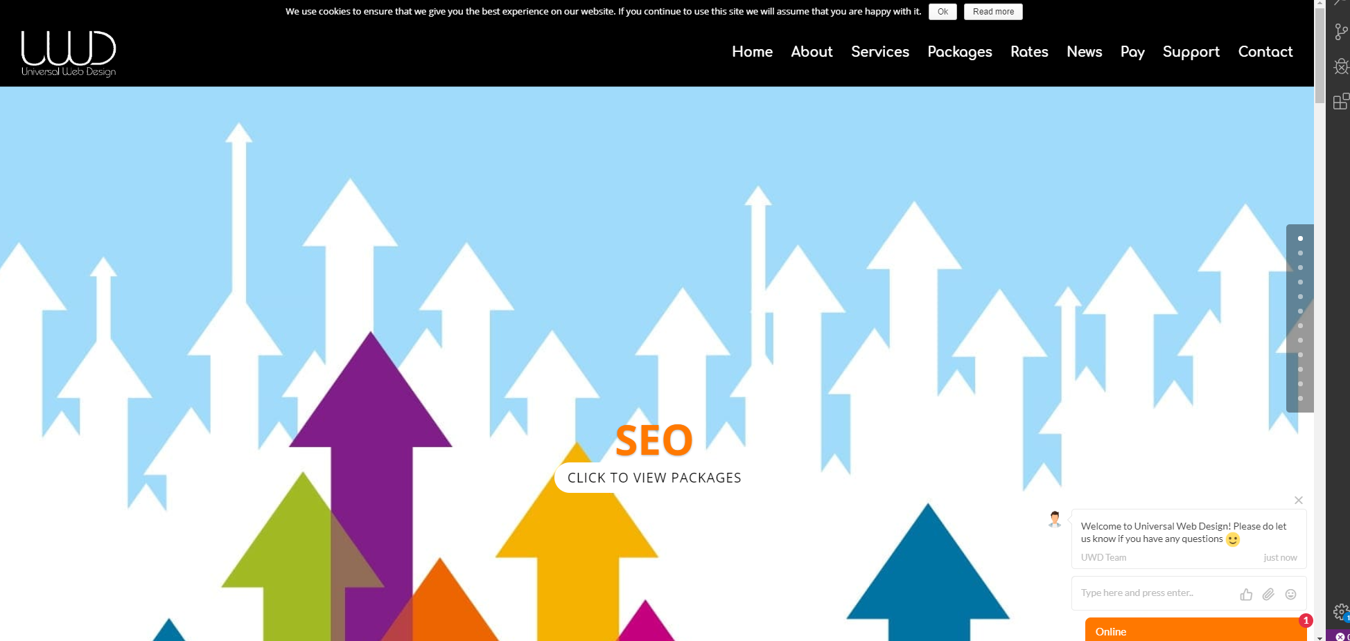

Universal web design has some really good animations, that are not present in Irene Webpage. The thing that motivates me is the live chat bot. This is something where users can contact her if they want to. It has a jquery used for its automatic generated numbers, this can be used to show her amount of experiences she has gained in the previous years. This is something that I really wanted to add in my design.

1. <https://www.itseeze-colchester.co.uk/>

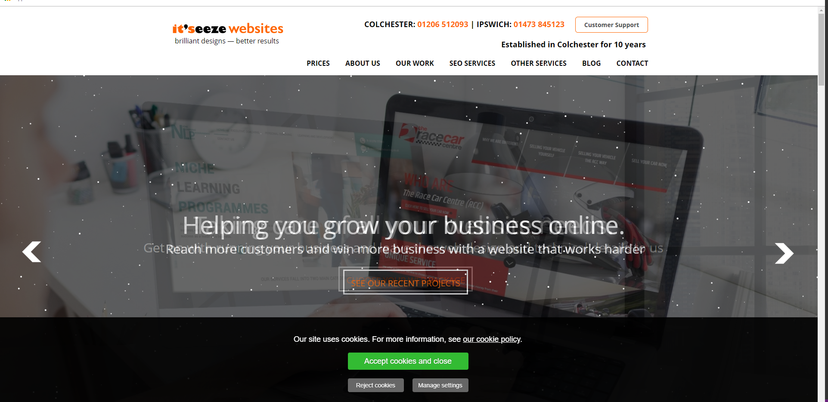

The Itseeze Colchester has really good banner with some snow animation on it. This is something new and want to add in my design. It has customer spport button on top which redirects you to other page and contacting them. Information is separated clearly.

**My Design**

This section I’ll describe about how my design is going to look like. So in my home page there are five navigation buttons placed horizontally. The first three of them are linked to same page on the page. The other two are created as a new page. The design fits the 480px and 980px of the screen.

**Layout**

I have put the menu bar in the left side horizontal corner of the screen because the menu is used to navigate the whole website. It is easier to use and go through different sections. It’s wide spread 90% with 20% box spaces in it. I have used light green background color, with a hover effect. The header banner has Irene Au name on it. Bold with font-family: Source Sans Pro, sans-serif. There are three boxes which represents different sections, First one is about Herself, the second one is about service, third one is about projects.

**Navigation**

I have added navigation links to all five of the buttons. When clicking on Contact it takes you that specific page. Where it displays her social media icons that can be used for contacting her. The blog button takes you the blog page. Where it then shows three different blogs boxes , Each of them have an external link to the main page of Irene au where they describe about that blog more in specific. This is some really good feature, if clients are interested in reading about her blog, then they are more than welcome. Services buttons has two other hover buttons added. One of them is yoga which redirect to her yoga schedule page. The other one is bout her event talks. The design has hover button shape. And is appropriately spaced out to the centre.

**My design brief**

The multiple web page website has a sections devoted to; Irene’s projects, the projects Irene has completed, The internet page was designed in a way to optimize Irene’s risk of being recruited by means of a pinnacle tier tech company. The webpage has been dressmaker with Irene’s attainable customers in mind. I have justified my diagram for Irene’s webpage to her.

The webpage permits users to bounce to unique content.

I have exterior links to different websites like one to her main event talk etc. The webpage has been designed to work for the modern day model of Firefox. I used fluid layout and a bit of adaptive design for my webpageThe website is thoroughly useful at each the sizes we had been required to make it for 480px & 960px.

**TASK 3**

**Full screen size (Desktop)**

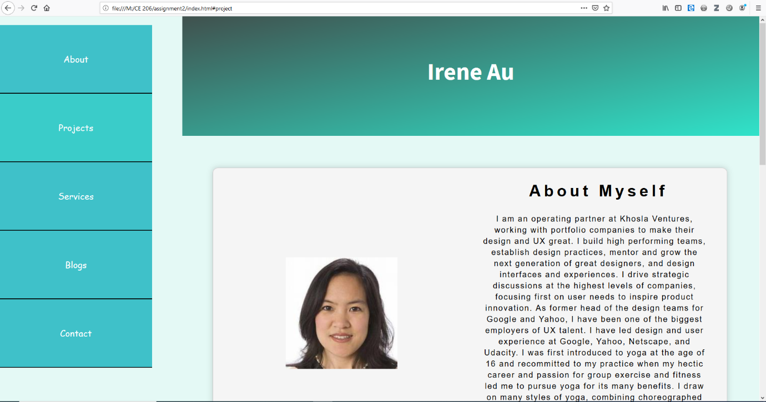

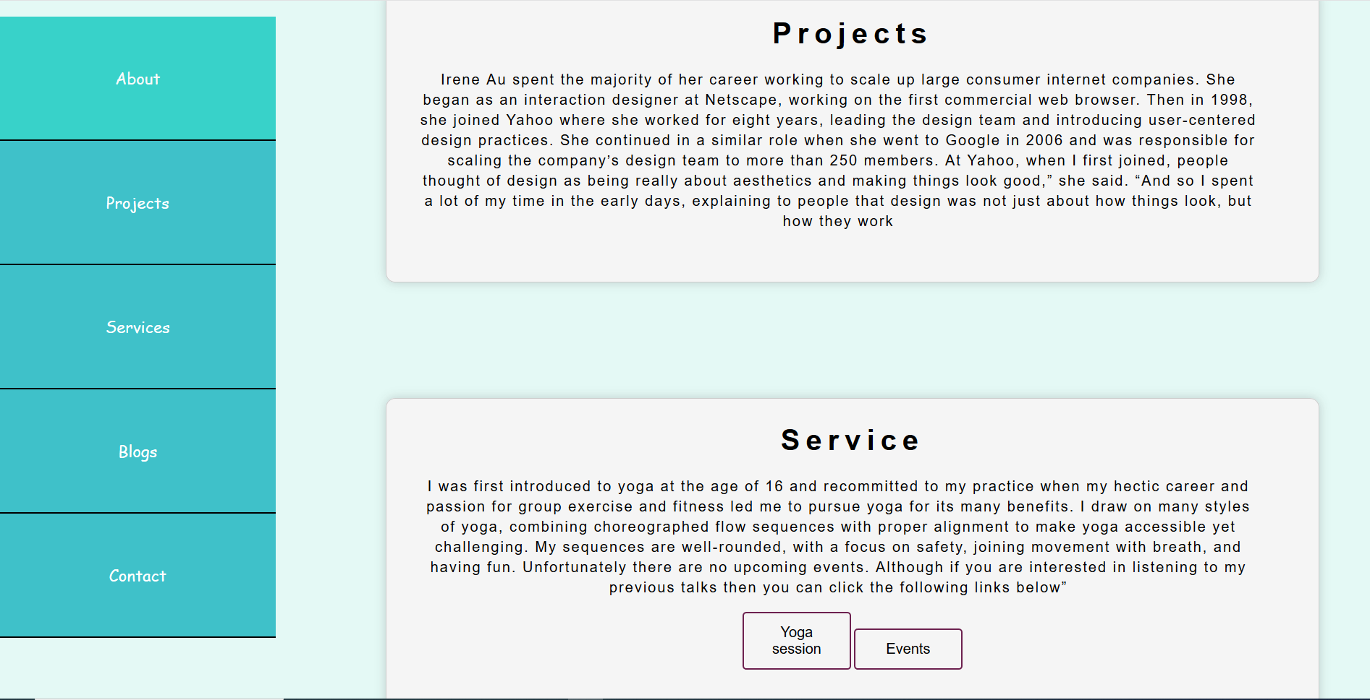

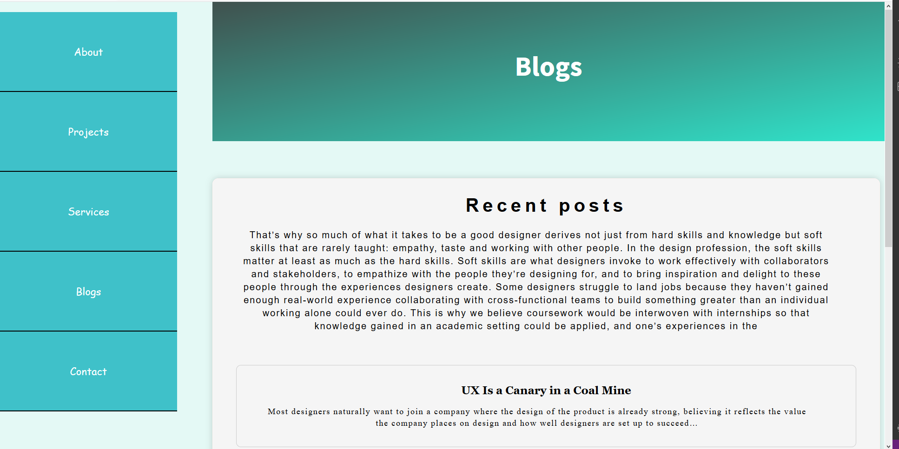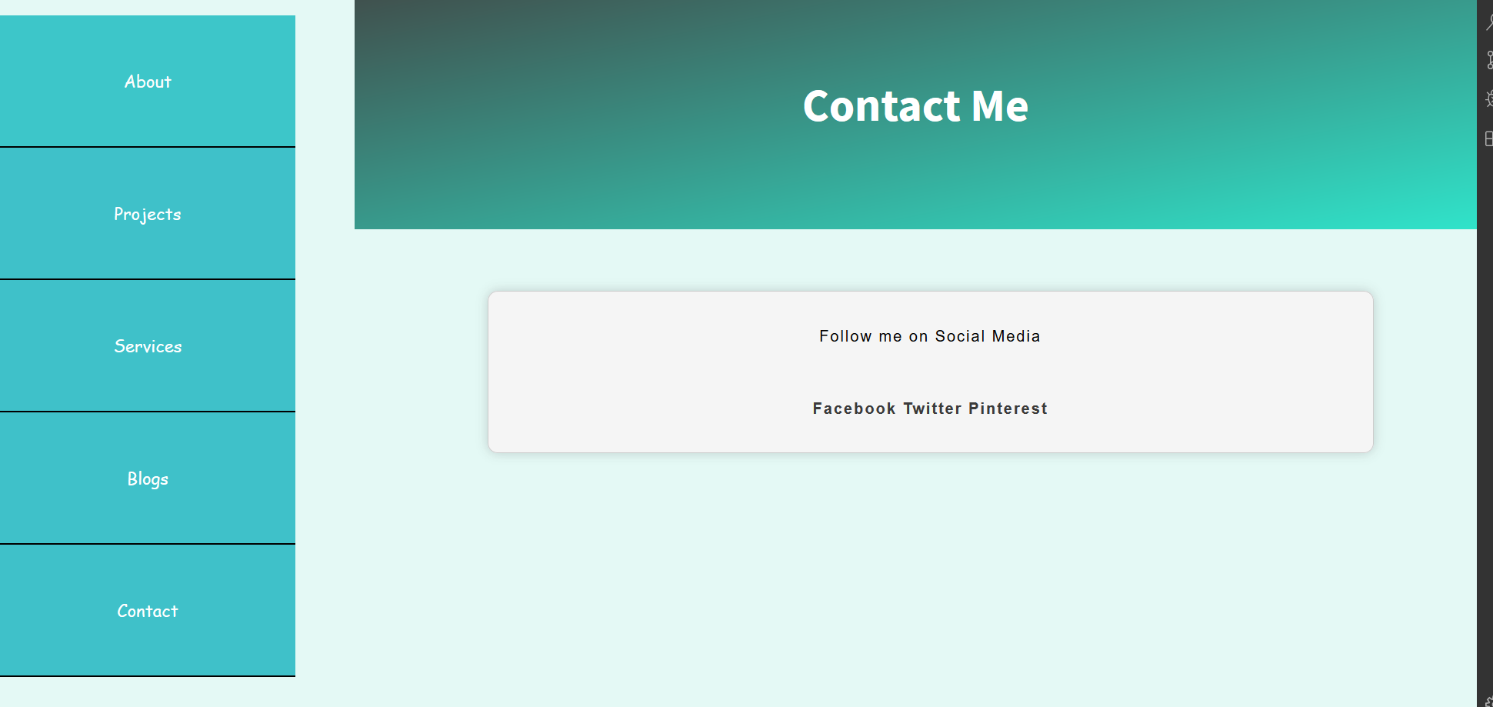

**Ipad screen size (980px)**

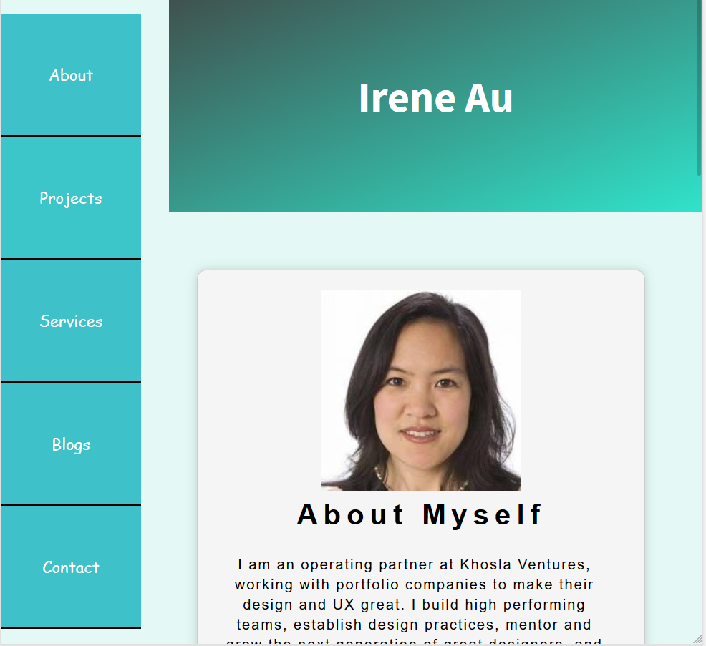

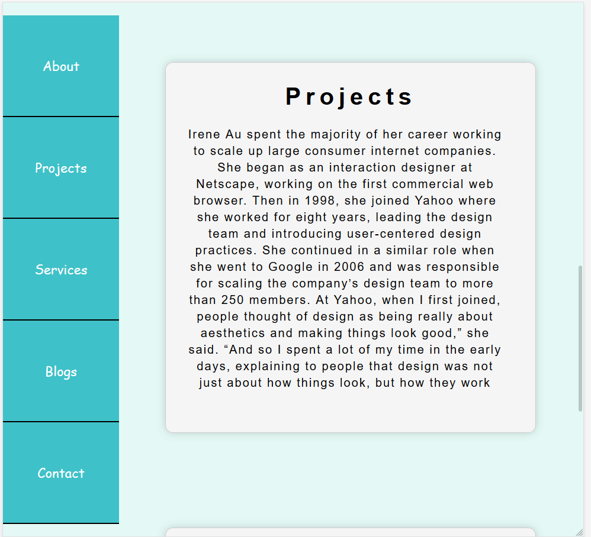

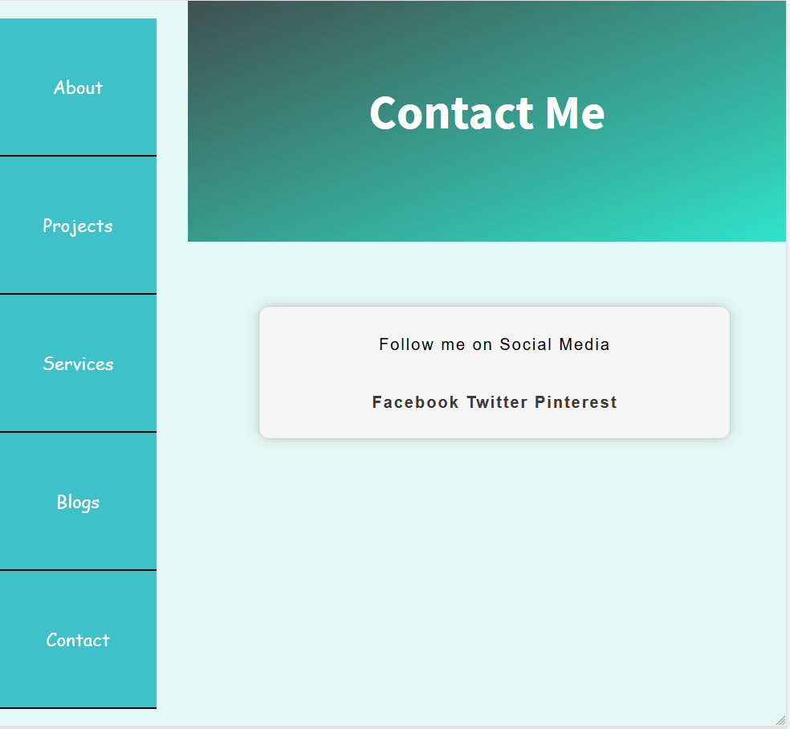

**Ipad screen size (480px)**

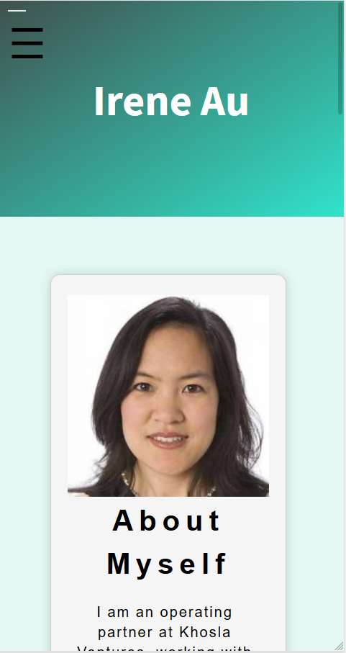

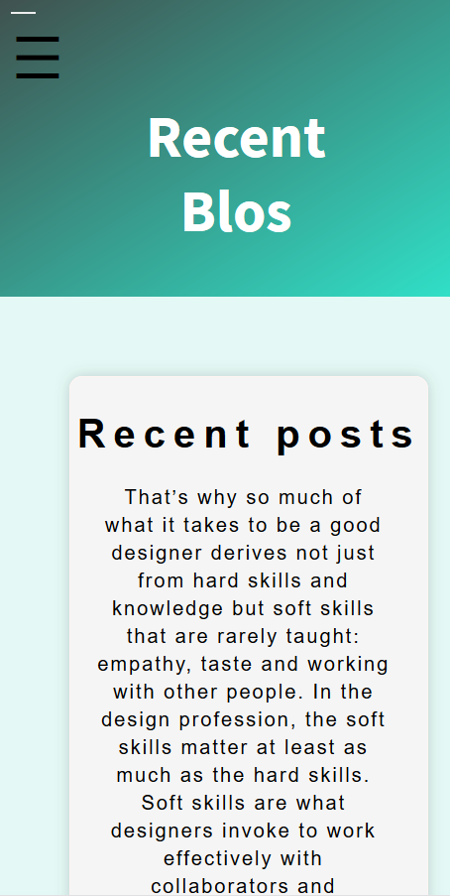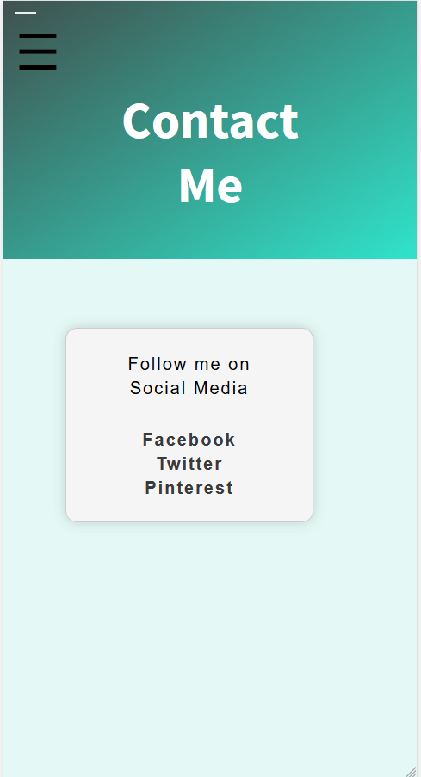

**TASK 4**

1. **Measuring Style**

**(Index.html)**

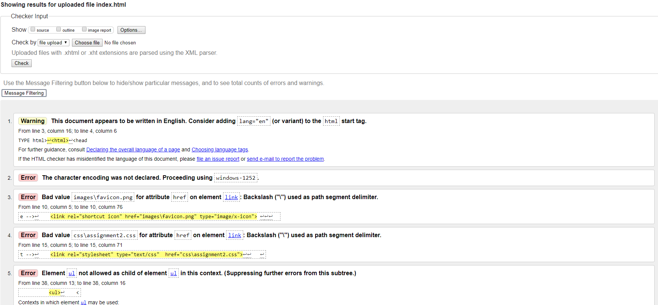

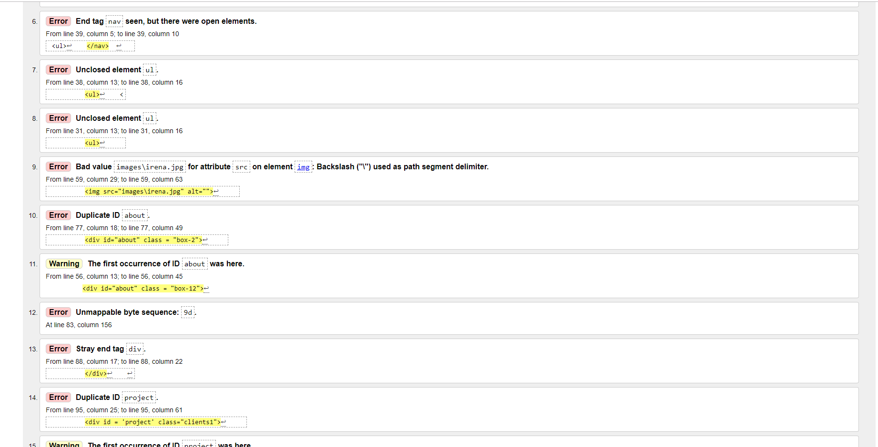

**(Contact.html)**

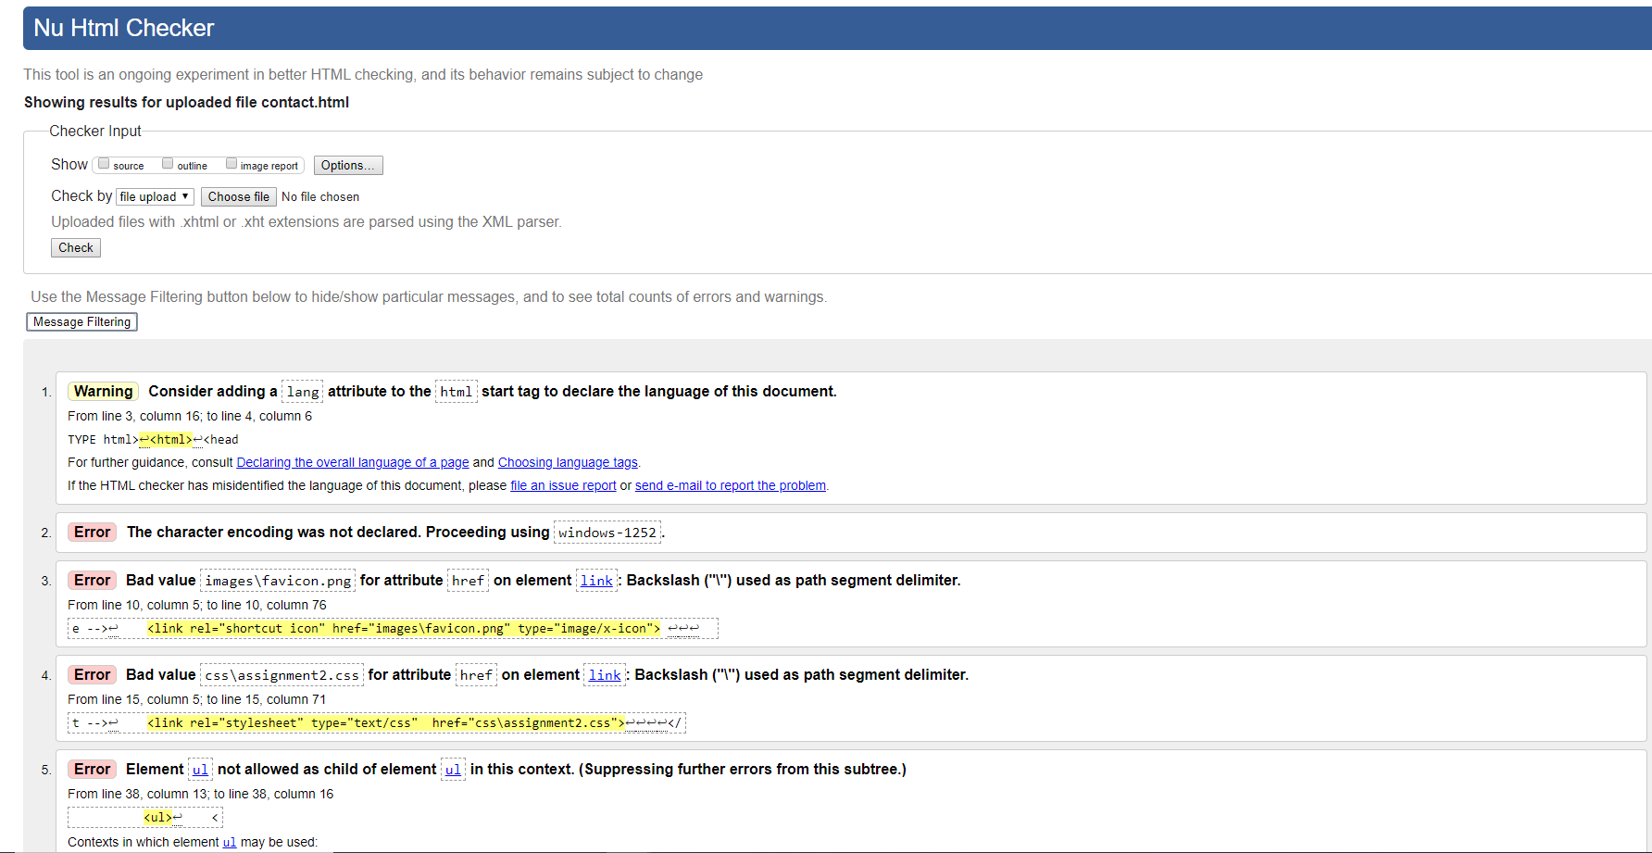

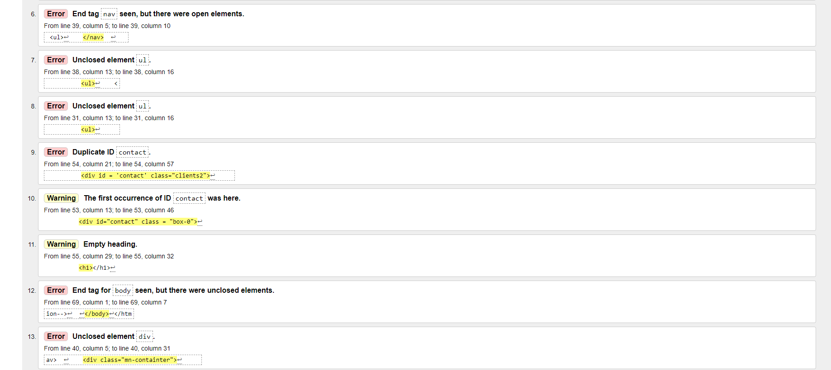

**(blogs.html)**

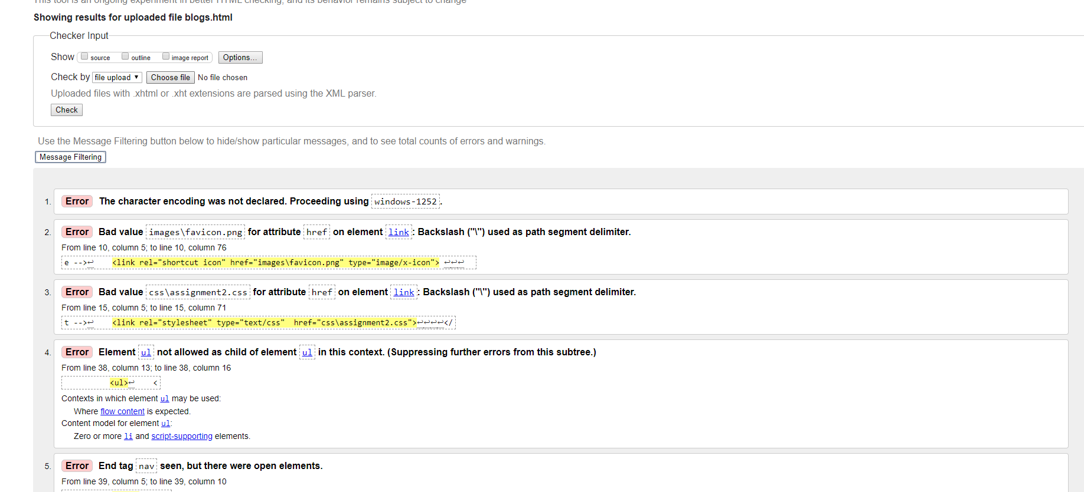

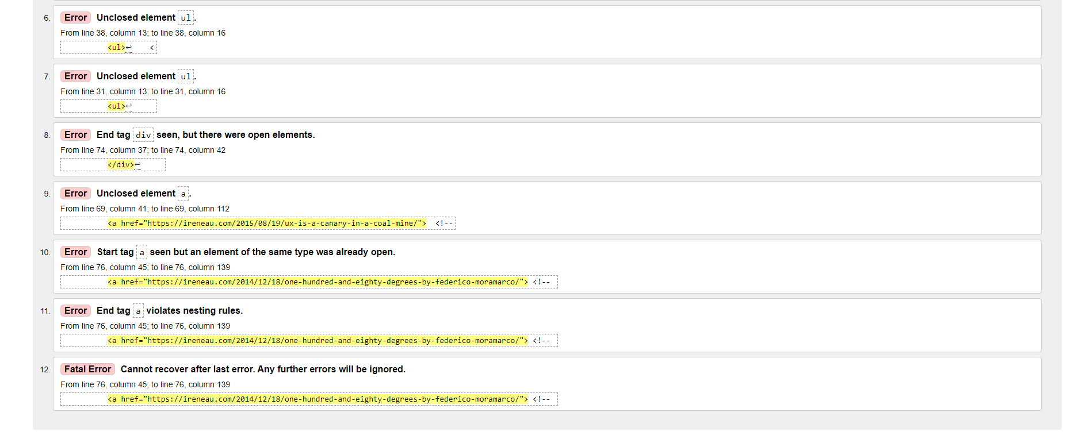

**(assignment2.css)**

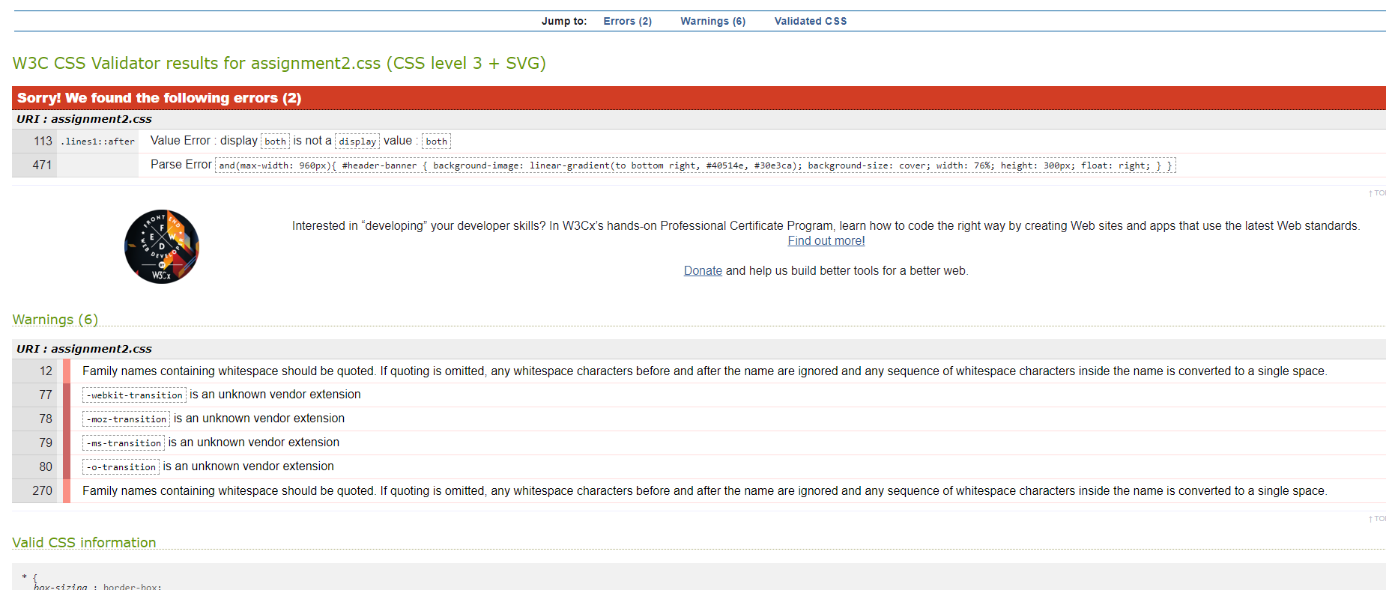

1. **Measuring Strategy**

**(Index.html)**

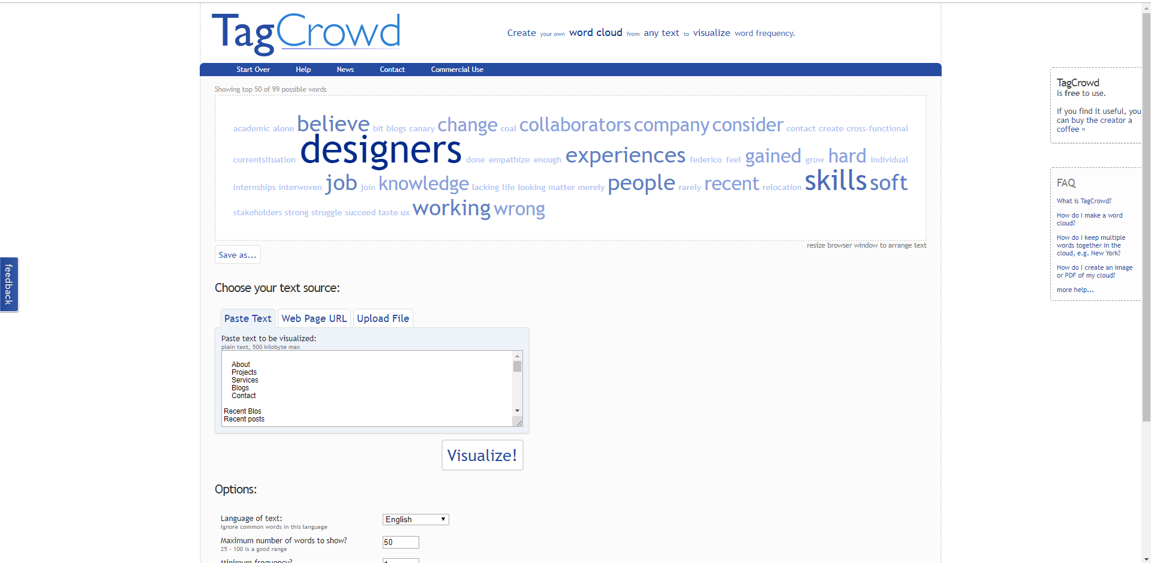

We can see that Irene has experience in designing as well as a lot of skills.

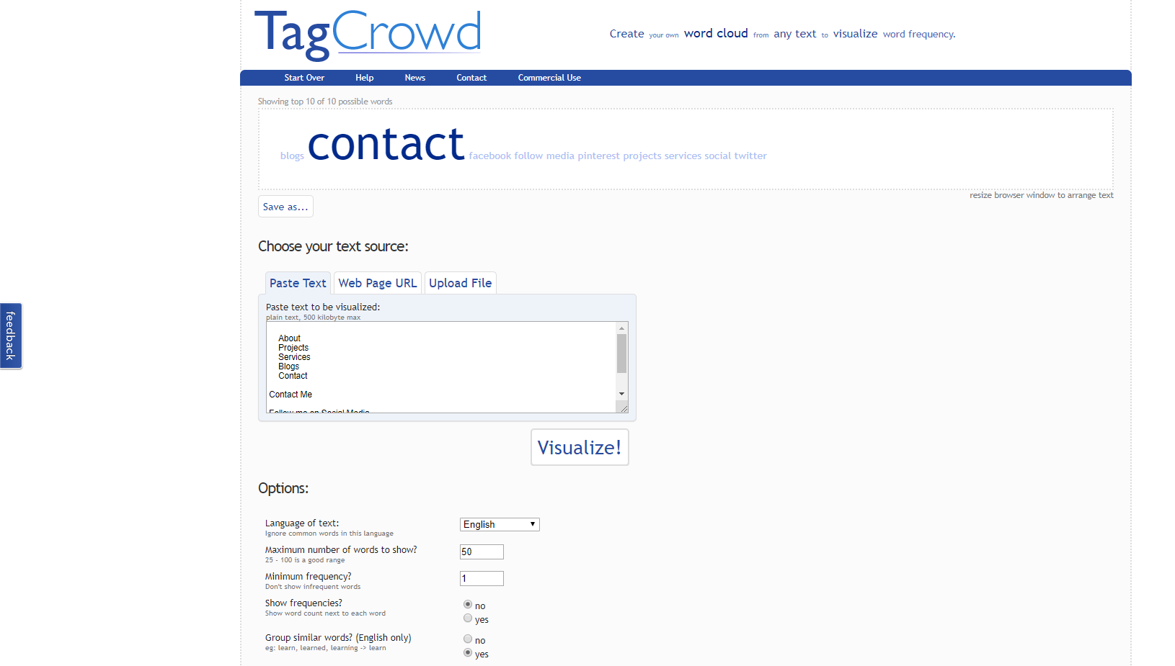**(contact.html)**

**(blogs.html)**

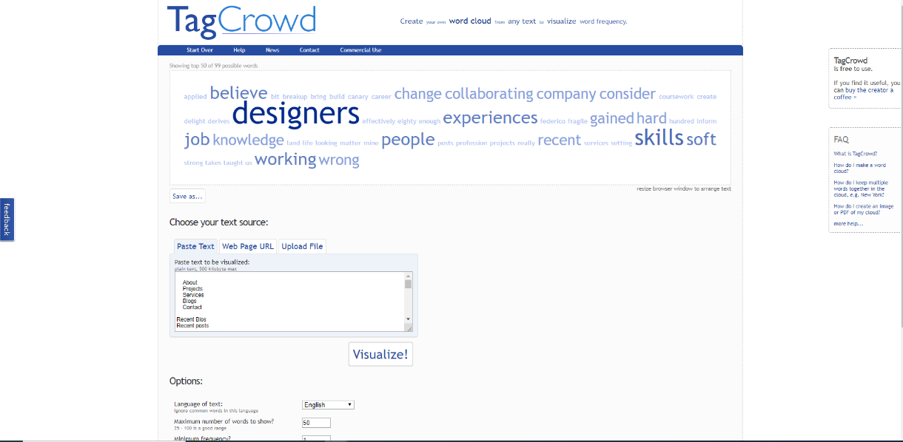

She has worked in a lot of companies such as Google etc. She believes experiences improves knowledge.

**Changes to improve my website**

* I would add more JavaScript
* I would add more animation to the website
* More Fluid
* I’ll make the website faster
* Improve general feel of the website
* Add more comments and pictures
* Try to reduce Eros in my html and Cuss

**My first test**

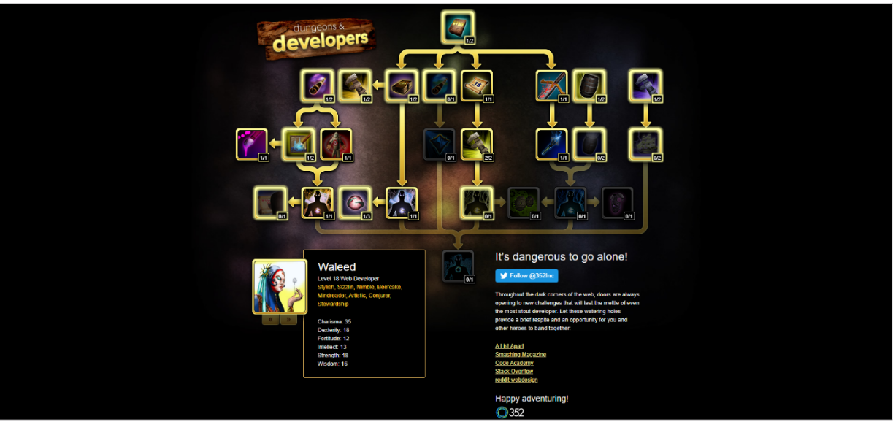

**My Second updated test**

